1. 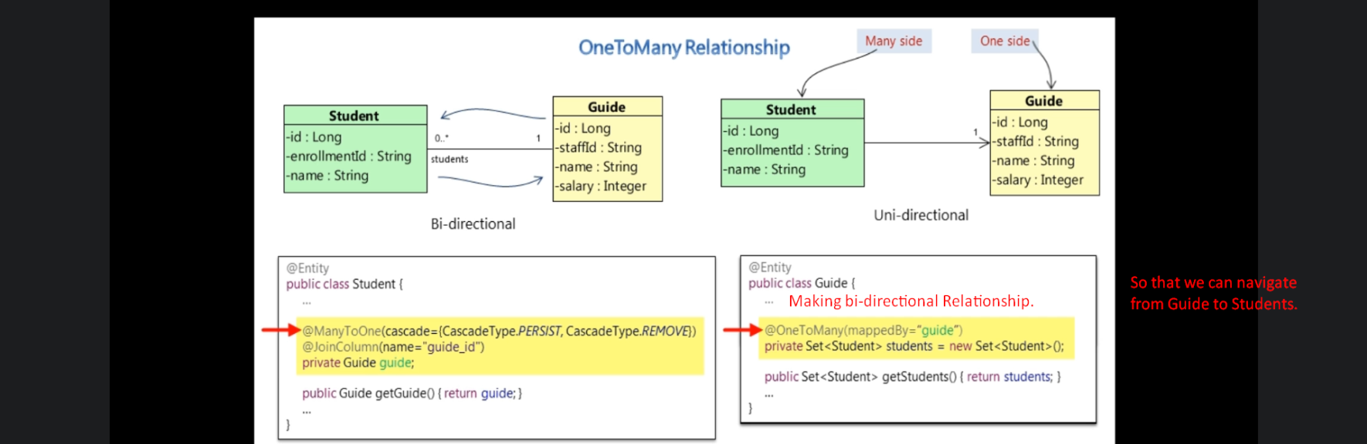
2. @OneToMany:
   1. One guide can have many students.
   2. This tells hibernate that this relationship “one-to-many” b/w the guide and student is mapped by the “guide” argument which is an attribute on the student side.
3. **Dirty Check**: When committing transaction, the whole object graph is updated into DB.
4. 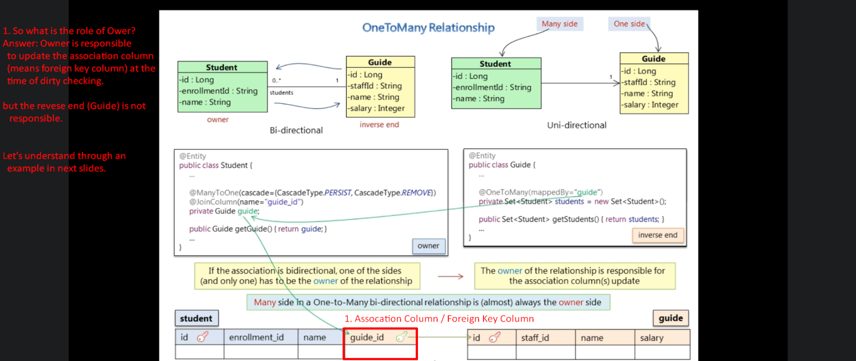
5. Jatin: Results by Practical Study.  
   First suppose you’re working on Inverse End. Means Guide Object.
   1. Creating a new Guide and saving it: Then you need to worry
6. 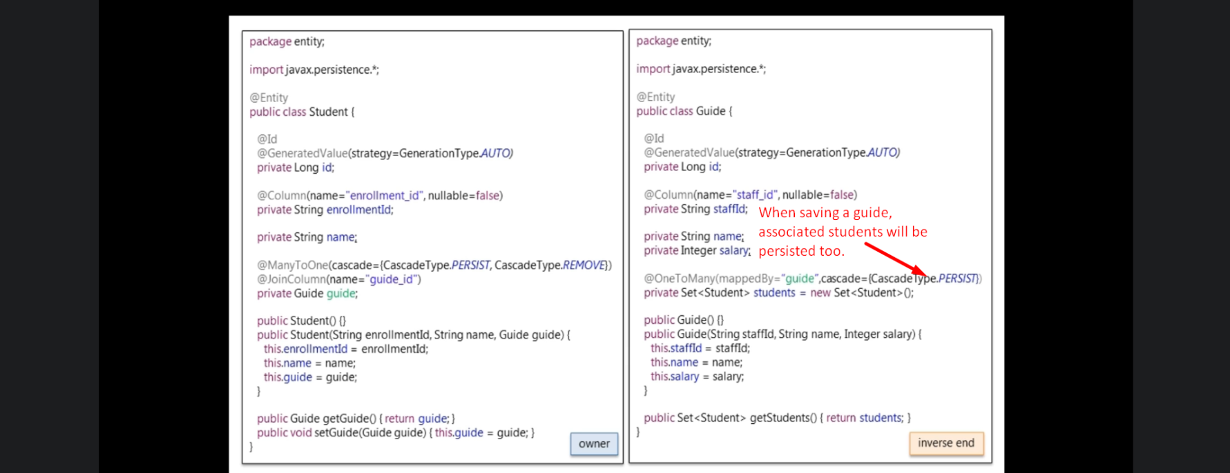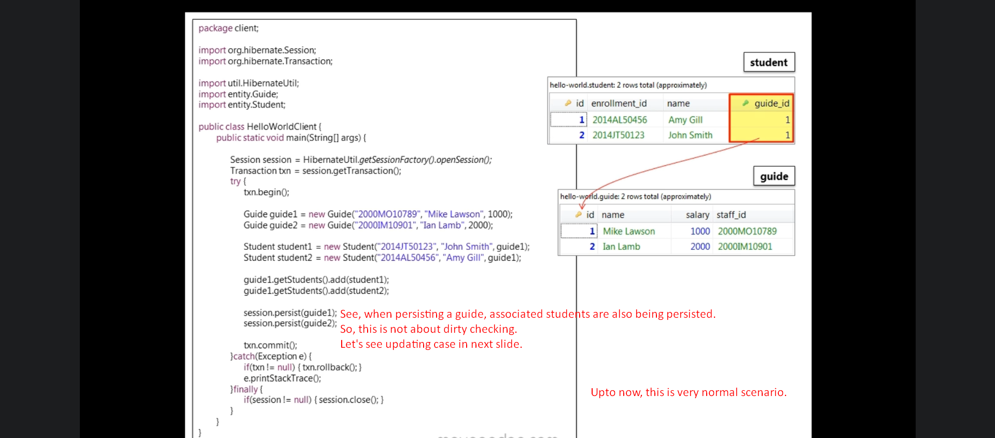
7. **Dirty Check**: When committing transaction, the whole object graph is updated into DB.
8. 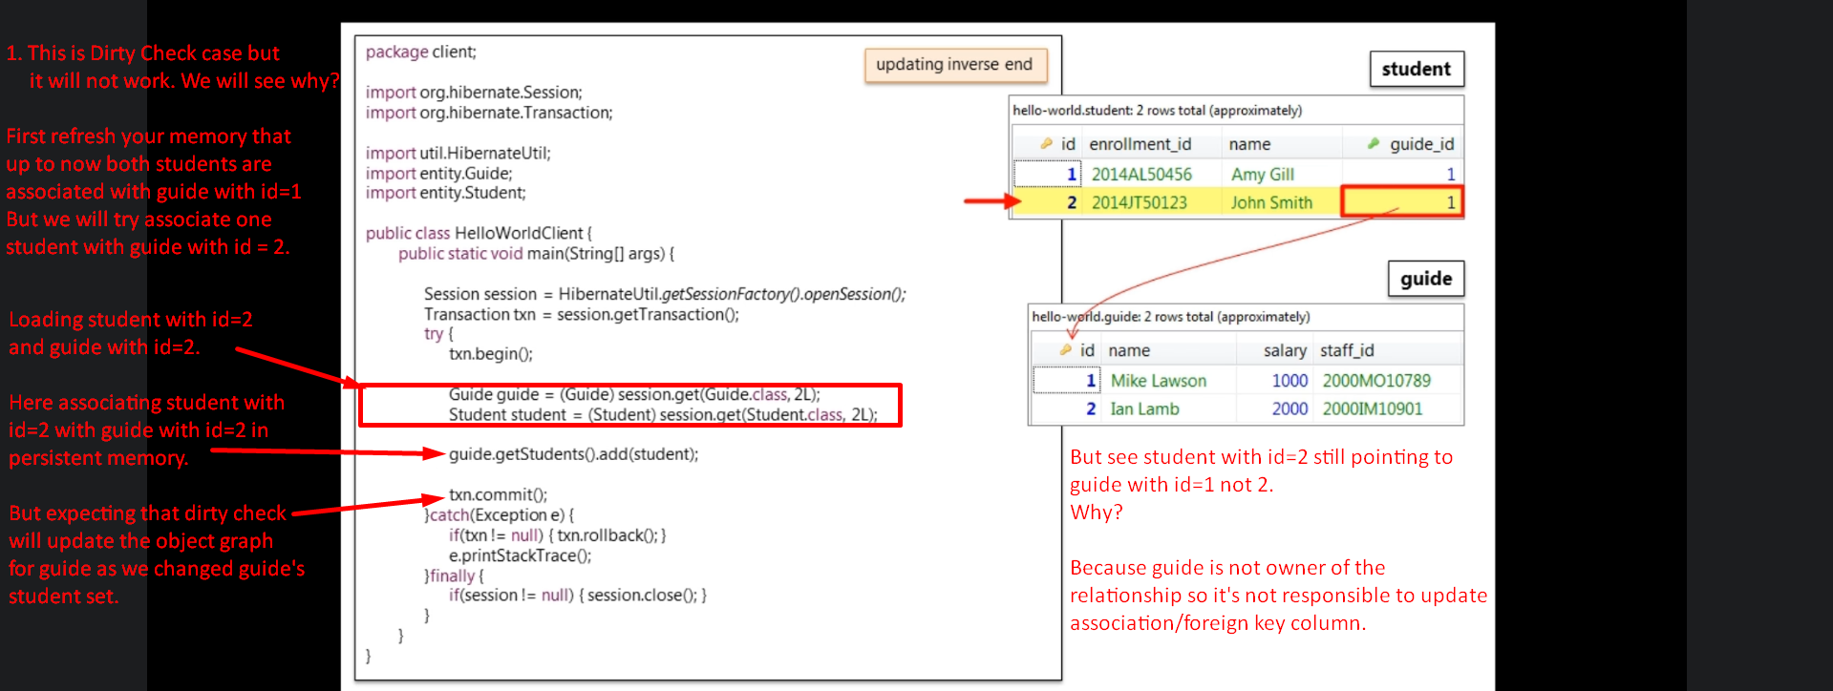Jatin: The above case is verified via practical.
9. 
10. 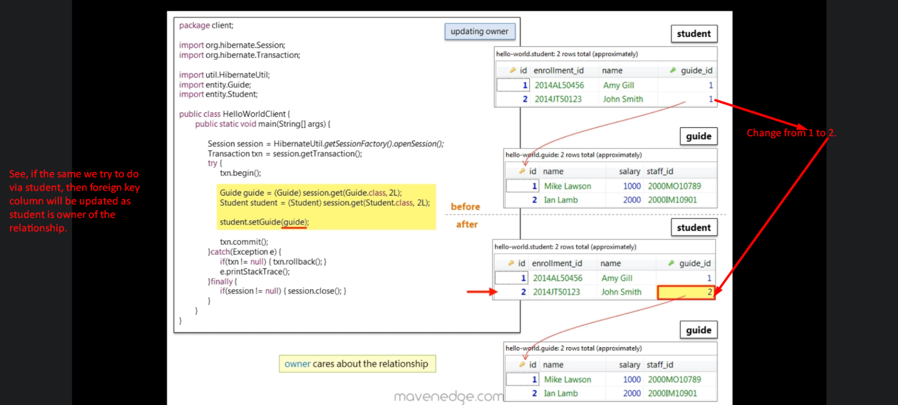Jatin: The above case is verified in Spring JPA example.
11. 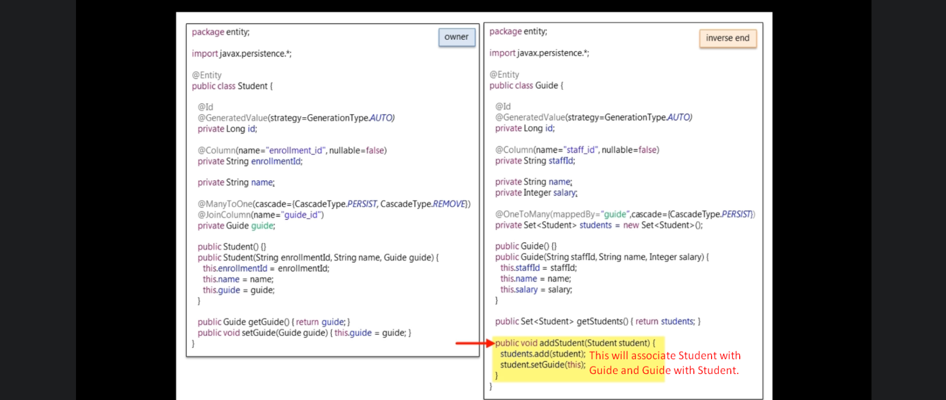
12. 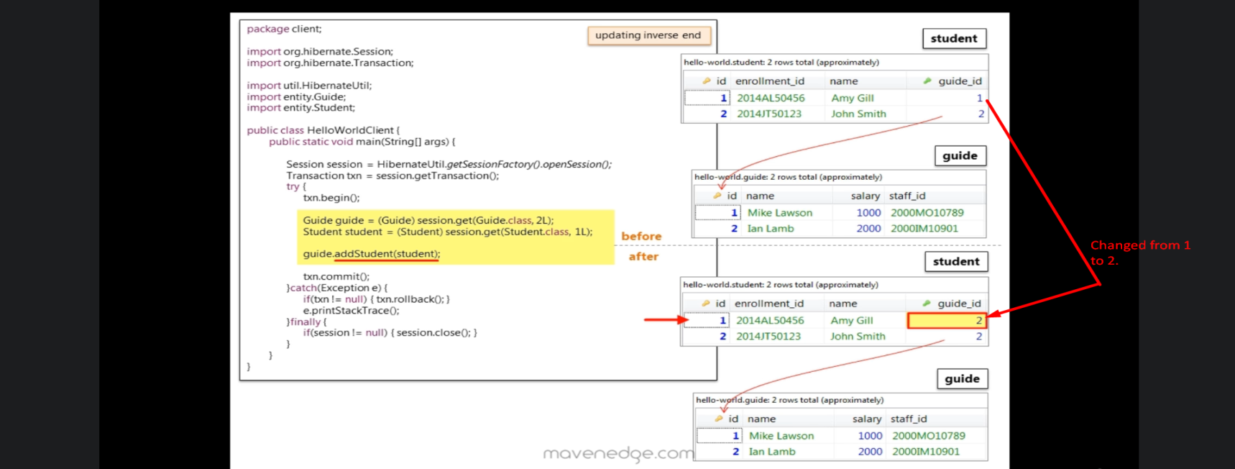
13. 